“Together We Learn”
Taylor Elementary School Framework
For Enhanced Student Learning
2018-2019
“Positive Attitudes Will Succeed”

Mission:

The mission of our school community is to educate, inspire and empower all students. We do this by providing challenging and enjoyable learning experiences. Together, as educators and parents, we believe that all students will attain their goals and discover the joy of becoming lifelong learners.

School Context:

Taylor Elementary School is a community-oriented school in the District of Taylor, fourteen kilometers south of Fort St. John. There are one hundred and fifty-two students attending our school. The student body is made up of 23% First Nation heritage. We have twelve teaching staff, and three support staff working with our students. Within the school, pre-school classes and a Strong Start Program operate, which have become an early learning part of our community and created strong bonds with students before they enter kindergarten here.

We continue to work hard to provide great learning opportunities for our students. We embrace BC’s new curriculum and seek to engage students in their learning everyday, focusing on big ideas and experiential learning. We integrate First Nation’s learning into the school, utilizing our Aboriginal Student Support Worker and other resources. We also have a leadership team, which organizes school events throughout the year. Our staff works hard to develop community spirit, as is outlined in our school song (Taylor Tigers/ Eye of the Tiger). We have set up a school-wide house system that promotes school spirit and teamwork. We have an extramural program that involves our intermediate students in a variety of inter-school sports, including cross country, soccer, volleyball, basketball, badminton and track & field.

We have a positive school-wide behavior support system (PBIS), and actively support positive behavior through assemblies and house team walk and talks, as well as through Tiger Paw rewards, for students that show PAWSitive (Positive Attitudes Will Succeed) behavior. We also emphasize Social Responsibility through lesson plans and our WITS program, which addresses any challenges that students face throughout the day, as they learn to Walk away, Ignore, Tell others to stop, and find a Supervisor to assist in finding a positive solution to their challenges.

Taylor’s unique setting provides outdoor activities that are not found in many schools. Our students have access to a hill that is utilized during recess and lunch. The hill is used for tobogganing and hiking throughout the year. The District of Taylor is a strong community partner and allows our students access to the skating rink, swimming pool, river, campground/park, golf course, community hall and curling rink. With these partnerships students are able to expand their learning beyond the classroom walls and regular classroom setting.
The parents of Taylor Elementary are actively, every day involved in the development and implementation of school initiatives and goals. The Parent Advisory Council (PAC) continues its tremendous support, through fundraising, special events, extramurals and special projects, including a week-long dance program that allows students to experience many different dances. Our PAC and parent volunteers provide tremendous support for our school and all of our students.

School Goals: These three areas were discussed by Taylor staff and parents and seen as three areas we would like to focus on in our school this year. By doing so, we would help students achieve their potential in learning and help them develop into responsible citizens.

1. To improve student’s performance in reading fluency and comprehension, by also finding ways to improve student engagement in reading.

2. To improve students’ sense of belonging and school pride.

3. To improve students’ performance in the knowledge, skills and attitudes related to Mathematics and problem solving.

Goal #1- To improve student’s performance in reading fluency and comprehension, by also finding ways to improve student engagement in reading.

Rationale: We see that Taylor students are not as fluent in reading as we would like and that they continue to struggle at reading comprehension. We notice that the students leave Kindergarten sometimes already at a disadvantage but see more low results from grades 3-6. We would like to focus on increasing students’ reading fluency and understanding as a result. We believe that if we are able to positively influence a student’s desire to read for enjoyment and increase their reading outside of school, then they should become stronger readers.

Data:
- Kindergarten Phonological Assessment- gives us a measuring stick for when students enter our school. This shows students results by the end of their Kindergarten year. The goal would be to have students in quartile 4 by June each year.

Year | Quartile 1 | Quartile 2 | Quartile 3 | Quartile 4
2014/15 | 4% | 22% | 26% | 48%
2015/16 | 0% | 4% | 29% | 68%
2016/17 | 0% | 24% | 12% | 65%
2017/18 | 0% | 6% | 12.5% | 81%

Students who do not reach quartile 4 will be reassessed and more closely monitored in grade 1.

- Grade 1 and 2 students do an assessment called PM Benchmarks at the end of their school year. This is their results:

Year | % Meeting or Exceeding Grade 1 | % Meeting or Exceeding Grade 2
2014/15 | 76% | 68%
2015/16 | 74% | 81%
2016/17 | 75% | 75%
2017/18 | 71% | 65%

- Grade 3, 4 and 5 students do an assessment called QCA at the end of their school year. The scores here represent those receiving a “3” or “4” score, which means meeting or exceeding expectations. Those who receive a “2” score, minimally meeting will not be shown here. This is their results:

Year | %At or above expectations  Grade-3  Comprehension | %At or above expectations  Grade-4  Comprehension | %At or above expectations  Grade-5  Comprehension
2014/15 | 43% | 64% | 58%
2015/16 | 27% | 60% | 26%
2016/17 | 48% | 50% | 64%
2017/18 | 29% | 47% | 40%

Year | %At or above expectations  Grade-3  Fluency | %At or above expectations  Grade-4  Fluency | %At or above expectations  Grade-5  Fluency
2014/15 | 43% | 76% | 76%
2015/16 | 72% | 80% | 68%
2016/17 | 68% | 73% | 64%
2017/18 | 76% | 84% | 72%

- Grade 6 students do an assessment called the “RAD” at the end of their school year. Percentages shown below are those students who again received exceeding or fully meeting:

Year | Meets or Exceeds-  Comprehension | Meets or Exceeds-  Fluency
2014/15 | 54% | 62%
2015/16 | 23% | 70%
2016/17 | 68% | 56%
2017/18

When we include minimally meeting into all of these percentages for comprehension and fluency we almost every time get to 100% of all students. Yet we as a staff, hope to get at least 75% of all Taylor students achieving fully meeting or exceeding in the future.

Strategies: Words Their Way, Reading 44, collaborative grouping by ability, leveled home reading, guided reading groups outside of class, assessment wall, smart reading strategies, library challenges- including Read-A Thon, expanding literacy resources to keep fresh material to engage readers. This year we are planning on doing school-wide home reading challenges throughout the year, in hopes to positively influence students to read. Staff have decided on a uniform tracking system to see if our efforts are getting students to read at home.

Communication to parents: Reporting periods, Fresh Grade, Student results on FSA’s, work posted in classroom and hallways.

Goal#2- To improve students’ sense of belonging and school pride.

Rationale: Students often seem disengaged or unhappy when being at school. Students have also expressed a desire to learn and a want to feel pride when they are here but sometimes become frustrated and feel they could use more help. Some students also indicated that they did not feel good as a result of teasing, unkind words, or bullying. As a result, we seek to improve each students’ experience at this school and wish to make it a more positive and safe place for all learners.

For 2018/19 School year we will be revising the questions to get more accurate data.

Data: Students were asked if they felt successful at school and the responses were recorded below:

95 Responses- (grade 2-6)

* Most students who responded “no” were primary students.
_____________________

They were then asked who they felt would help them while here:

How many adults do you feel will help you in this school?

95 Responses- (grade2-6)

- We found it encouraging that half of all students felt more than three adults would help them at school, but discouraging that 7 felt no one would help them.
_______________________________________

When students were asked what would make the school a safer place to be only 15 of 96 students reported not being teased, laughed at, or bullied. While this number is still too high, we as a staff felt it would be higher. Almost as many (10) responded that “nothing” would make this a safer place to be.

Other Student Responses:

- 39 students indicated that Math was the hardest thing about school.
- 32 students responded that gym was the easiest and 36 students responded that playing or doing sports made school more enjoyable.
- 19 students stated “learning” is what made school more enjoyable!
- When students were asked what could make school easier, 22 responded getting more help while 11 stated they had to try harder.

As a result of this survey, teachers have already rewarded students who try hard and do well in Math, more gym time and sports.

Strategies: Ways we are striving to make the school a place where students want to be.

- Students will use their W.I.T.S. (Walk Away, Ignore, Talk it out, Seek help from adult) when conflicts arise at school. W.I.T.S will be talked about and this language will be used in dealing with all conflicts in our school.
- PBIS (Positive Behavior Intervention Support)- we will hold an assembly twice in the year to review what good behavior looks like. We will also walk through all areas of the school and allow students to build a matrix of Pawsitive behavior.
- Students who display Pawsitive behavior will receive Tiger Paw rewards that will be displayed prominently in the school.
- Students who show great behaviors may be visited in their class by the Taylor Tiger Mascot to recognize their behavior among their peers.
- We will have staff work on classroom strategies such as Mind Up and the Friends Program with all of our students.
- Presentations throughout the year from cultural groups and community partners will reinforce good behaviors
- We will practice the Taylor Tiger song multiple times throughout the year, which goes over expectations for students.
- Students will learn teamwork and collaboration through clubs and sports teams
- We will install a “Buddy Bench” outside
- We will hold assemblies three times a year to recognize students who achieve great citizenship, academic excellence and show merit.

Communication to parents:

- Teachers and staff will use positive phone calls to parents when students succeed in school.
- Parents will be invited to all assemblies and be able to witness their child sing the Taylor Tiger Song.
- School Code of Conduct will be posted on our website.
- Tiger Song lyrics sent out to parents.

Goal#3- To improve students’ performance in the knowledge, skills and attitudes related to Mathematics and problem solving.

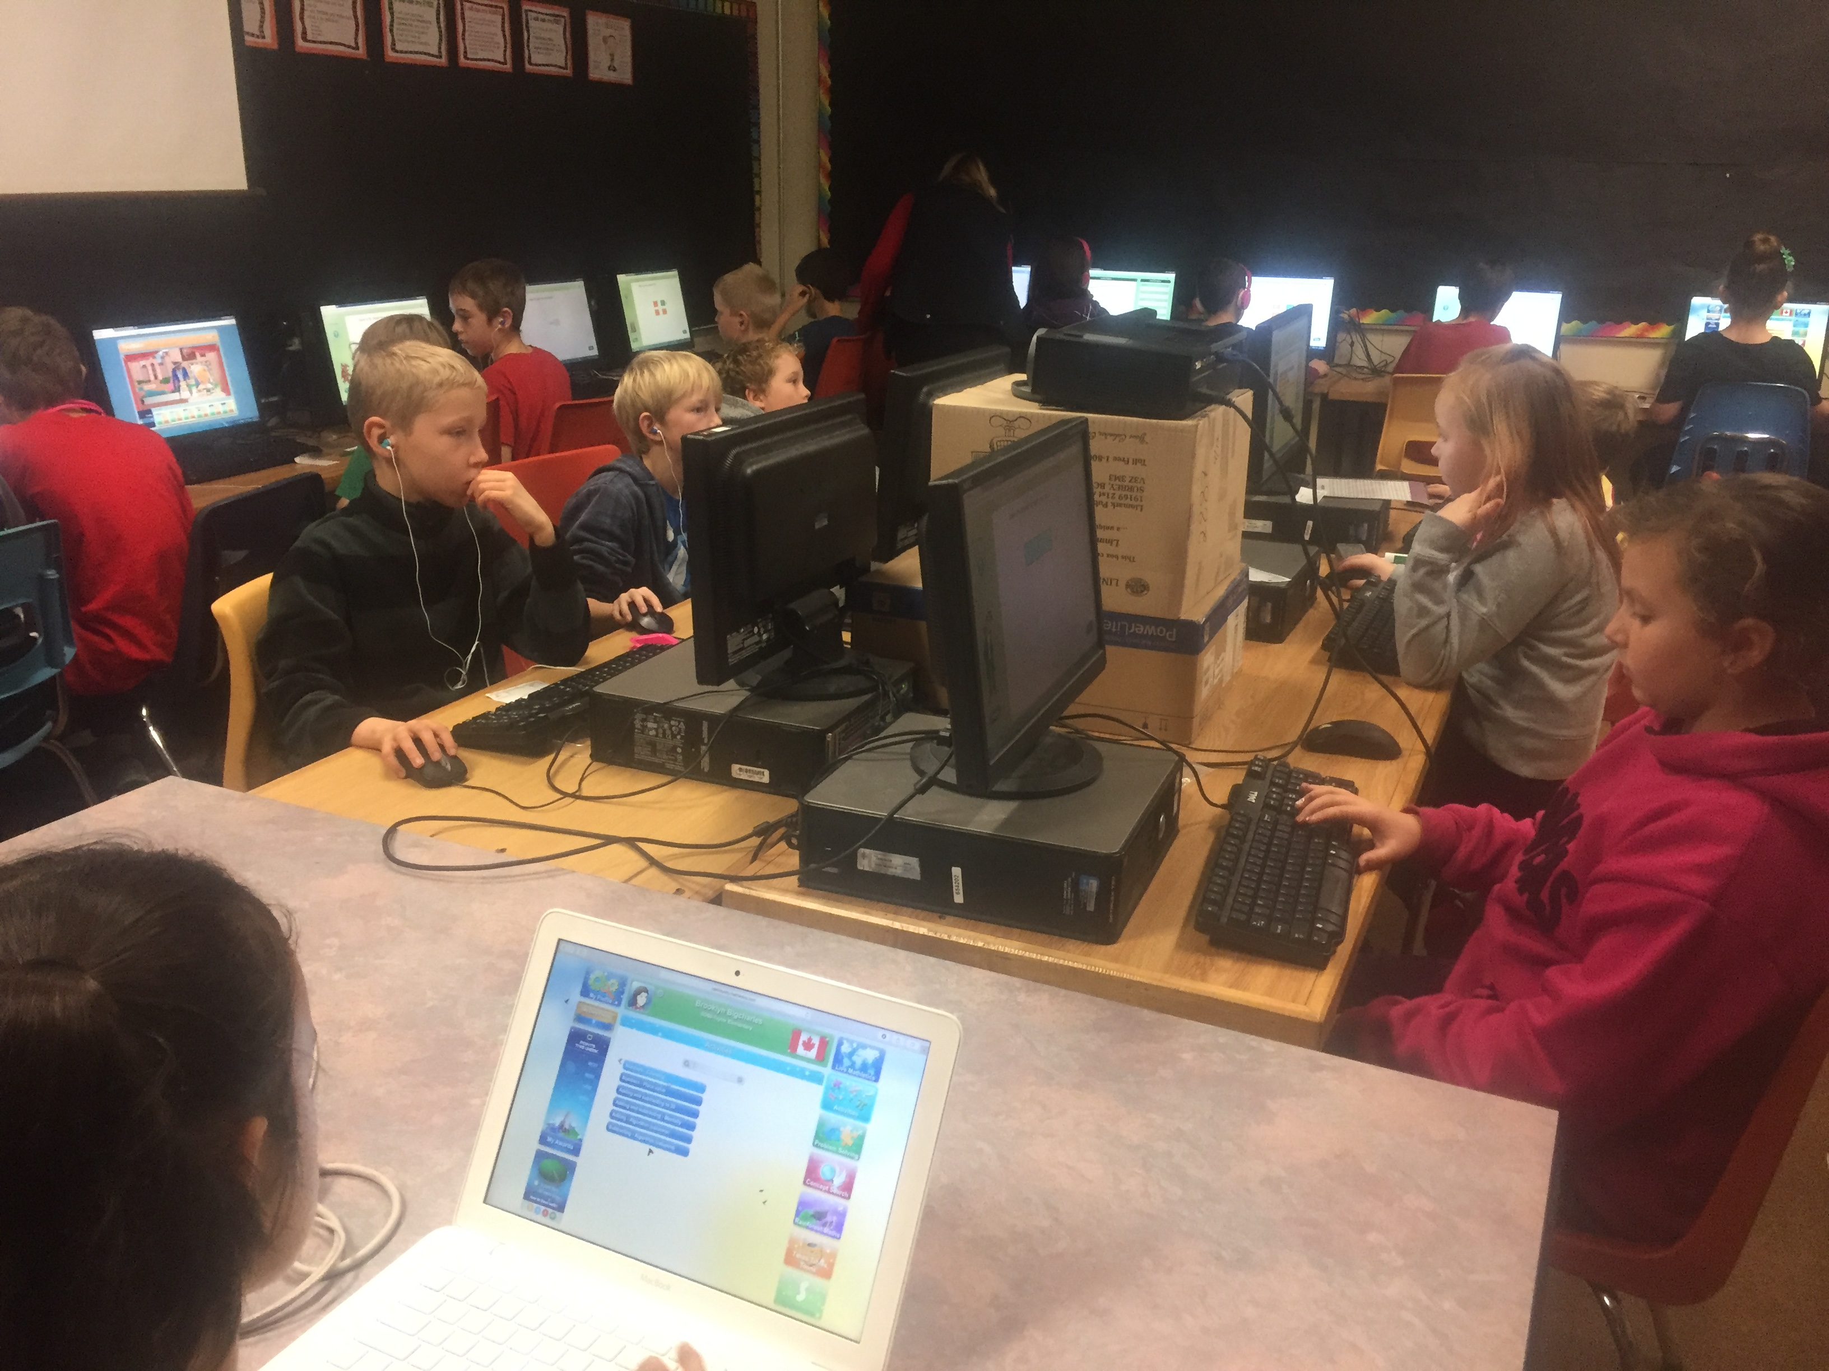

Rationale: Students are having difficulty solving problems that have multi layers to them and with mathematical thinking including number sense. Added instructional focus in this area should help students.

Data: All students wrote the new district math assessment this year to establish areas of concern. Teachers are using that data to help focus their math instruction.

DNA- District Assessment
Year | Grade | Computation Score- meets or exceeds | Number Score- meets or exceeds
2016-17 | 2 | 92% | 92%
2017-18 | 2 | 89% | 75%
2016-17 | 3 | 73% | 76%
2017-18 | 3 | 57% | 57%
2016-17 | 4 | No data | No Data
2017-18 | 4 | 73% | 62%
2016-17 | 5 | 72% | 60%
2017-18 | 5 | 3% | 19%
2016-17 | 6 | 50% | 18%
2017-18 | 6 | 44% | 44%

As a result of these extremely low scores, we are focusing much more time and resources to Math in Intermediate grades.

Strategies: We will attempt to gain interest in math by making math instruction more engaging

- School-Wide Mathletics- An online program that engages the students by making challenges with rewards that mimics the way many young students play online games at home.
- Math Coaching- teachers here collaborate with each other and will seek math coaching from district itinerants.
- Use of math manipulatives.
- Focus on number sense throughout the year using repetition in small chunks and math minute activities.
- Students will practice problem-solving skills regularly, through grade specific focuses using resources such as Real World Math Problems and a Math Problem Solving Tool.

Communication to parents:

- Focus on math when reporting on informal report cards.
- Reports cards
- Share FSA data

